Telusko: Core Java 01

002 FUNDAMENTALS OF PROGRAMMING AND COMPUTER
yes my que is why it is incompleted after compling process
y becoz of time complexity.
can u discus assemble and compile again
Assembler -> It is a software which is used to convert ALL to MLL
Compiler -> It is a software which is used to convert HLL(symbols) to MLL
Sir , Do Processor have memory? How can it can recognize repeated command take
from cache?
Cache data would be recognized by the software(os or c/java)
can you please explain semiconductor thing again .. that was bit confusing
SemiConductor -> it is technology made of diodes which can understand
only 0's and 1's.
Sir, why we are writing the program on ram if by the end we have to save on HDD...?
RAM -> volatile data and it is fast in execution.
HDD -> nonvolatile date and it is slow in execution.
sir once recap .objfile and .exefile
.obj file -> It is incomplete file with instructions in MLL only
.exe file -> It is a complete file with instructions in MLL which can be
exected by CPU.
what is register ?
register is small storage unit on CPU.
Inside register CPU uses frequent instructions for quick execution.
sir byte is exactly what?is it the memory space in ram or what?
Storage medium
file -------> Harddisk
byte --------> RAM
register-----> CPU/Microprocessor
But if library files are binary then how can we see their code like if they are
normal files??
execution.
libary files refers to instructions in MLL, these files are linked during
In c/c++ we have library files...
when file is loaded from hdd to ram it gets stored in byte?
Yes, that process of loading is taken care by OS(Operating System), becoz CPU
understand only MLL.
Roadmap for learning JAVA
JAVA -> JSE(CoreJava)
JEE(AdvancedJAVA
prerequisite-> HTML,CSS,JS(basics)
DataBase -> MySQL,Oracle
if i open one application every day but every my laptop was on and off so that
time processor what will use cache or RAM to open application?
Switched Off -> Os shutting down(memory will be cleaned)
Logged off/sleep mode-> Os is not shutting down(memory won't be cleaned)
data will be there on ram as well
as on cache.
does compiler replaced assembler completely?no
now we r using only compiler right instead of assembler?
yes because we use HLL to write instructions to CPU.
is linker available in java also?
yes, do wait till JDK Architecture.
sir total number of sessions in advanced java & SPRINGBOOT MICROSERVICES
AdvancedJava - 50+ hours
SpringBoot + microservices -> 80+hours
sir when we download c language what all we get?
do we get compilers linkers loaders library files everything?
Yes we get all as one .exe file
differnce b/w HDD and SDD?
not required to know the architecture.
i was just curious about cache memory...is it precent in MP or
its separate memory...its not related to our course i just curious about that?
CacheMemory avaialbe inside cpu only for faster execution and its size is in
MB(very limited)
how can you run without program without saving then slow when we save and run?
not possible, we need to first save only then OS will load that file and keeps
it in RAM for execution.
sir how exactly will ALL look like ?
ADD AX,BX
mov CX,#5
I'm using jdk19 and latest version eclipse but I'm creating java project and
run hi say error. Then i connect my dashboard support and Mam also trying
4 time but not solved my problem she's last time say delete your jdk19 and
eclipse and install again and I'm same step follow but my problems are not
resolved.
JDK19 if u r using , then eclipse should support jdk19 version.
latest eclipse would support only jdk17 version.
Best LTS(Latest stable version) use JDK8 or JDK11.
Difference b/w linker and loader?
linker-> it is a software which is use to link .obj files with library file and it
also makes
the .obj files executable(.exe files)
loader-> It is a software which loads our .exe files into RAM for execution(CPU).
Sir data is transferred from RAM to Processor through BUS but where does the
change takes place from (byte- MLL) as processor understands only MLL
Harddisk -> files are present
User will say to run one video file,now os will come into pitcure for loading
the files
from harddisk to RAM for execution.
OS will convert the give file into .exe file during loading and it will be
sent in the bus
for execution(CPU).
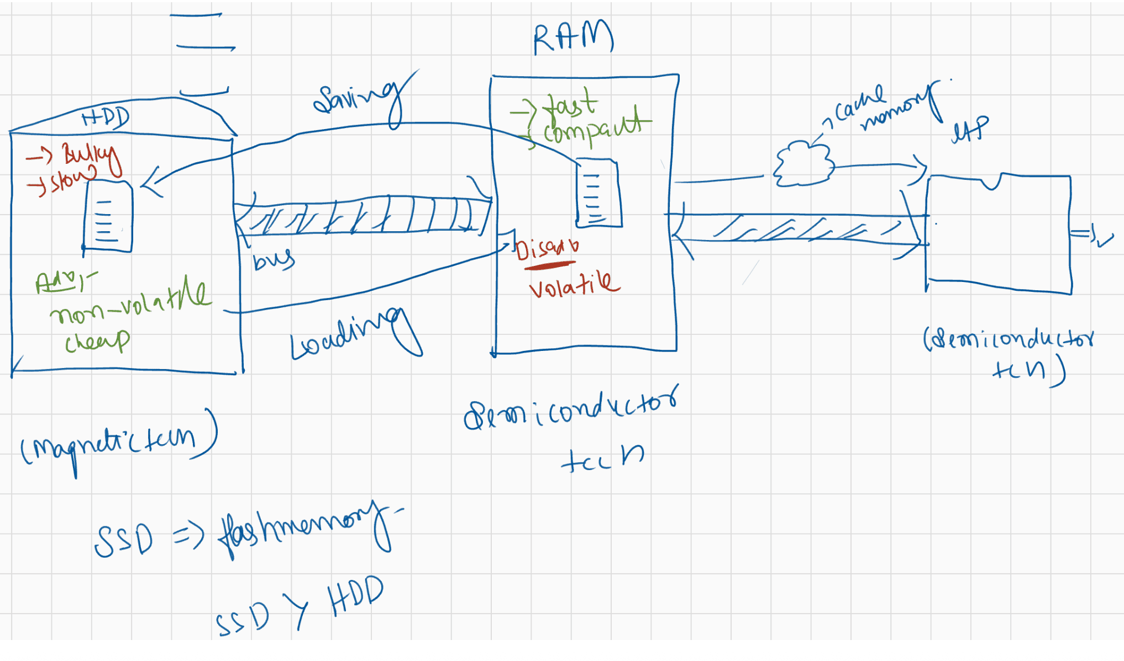
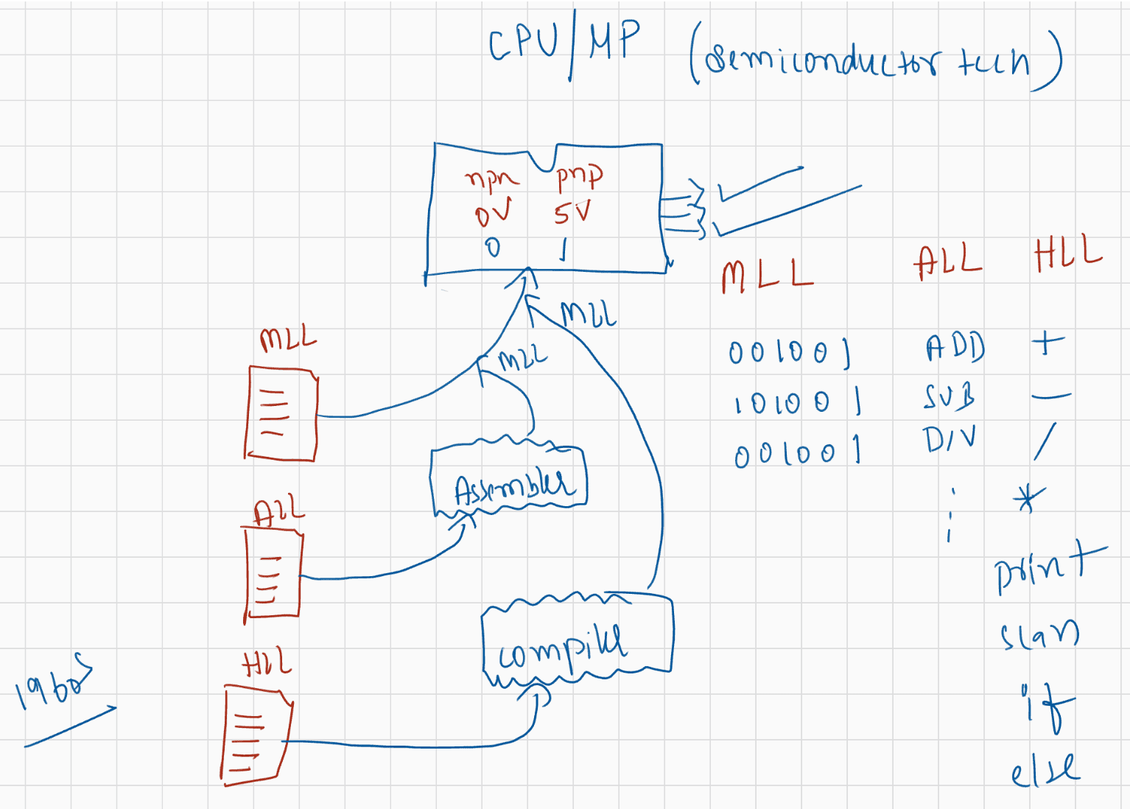

003 ROADMAP AND FUNDAMENTAL OF JAVA

what is difference between MLL and byte code?
MLL -> contains instructions in 0's and 1's
Bytecode -> It contains instructions neither in HLL nor in MLL
what is architectural nuetral?
Write code once in any platform and run the code in any other platform without
worrying its architecture.
Architectural neutral -> Write Once Run Anywhere(WORA)
what is jit?
JIT -> Just In Time Compiler(refernce to JDK Architecture)
jvm comes between the platform to make independent...where c stucks...
on which level. briefly explain please
C language -----> compiler------- -> .obj file(contains instructions in MLL)
JavaLanguage---> JavaCompiler -->.classfile(contains instruction neither in MLL
nor in HLL)
.obj file -> windows(run)
-> linux(no output)
-> mac(no output)
Architectural Neutral/Platform independence/WORA
.classfile -> JVM(windows)
-> JVM(linux)
-> JVM(mac)
can u explain about the how the jvm works?
.class file(byte code) -> JVM (reads bytecode in interpretetion style)
sir jvm is platform dependent ?
yes jvm is platform dependent.
sir wht is obj oriented lang?
Obj oriented language means writing the code using the principles of Oops.
eg: inheritance,polymorphism,abstraction,...
Q>
If we compiled our app in jdk18 and uploaded it in the cloud. Will it cause
problems in the future after it is not supported?
No probs becoz java provides backward compatability.
Q> jvm contains java compiler or java compiler is seperate?
JDK => Compiler + JRE
|=> JVM + library tools
Developers(JDK) -> write the code ,test the code and run the code.
Enduser(JRE) -> just run the code
Q> can you explain how java works as interpreter in depth?
.java ----> .classfile -------> JVM(interpreter)
|-> line by line
execution.
Q> Can you explain what is HLL if possiable is it source code or bytecode?
.java(sourcecode/HLL)
|
|compiler|
.class(bytecode/neither MLL nor HLL)
|
|JVM
|
output
Q> Sir what is command to check java version
java -version
Q> Sir Java LTS version automatically updates or we need to uninstall the
version and install the latest version of LTS?
uninstall and install(suggested to just install jdk11(LTS))
Q> Can we see file containing Machine Level Code Sir like how u showed for
Byte Code?
yes possible,but not in java(becoz output file is not generated in
java)
Q> sir what is jar?
jar -> Zipping of .class files is called as "jar" file
It stands for Java Archieve file
Q> is .class file is a complete code??
.class file is not complete file,internally it becomes complete with
the help of JVM.
Q> what is flash memory sir?
It is ROM data(Read Only memory).
It is a information w.r.t vendors(linux,unix,fedora,windows,mac)

004 DOUBT
Note:
Today is only doubt Session
we are just clearing the doubts by taking QA
Attendance is not taken into picture
Doubt clearing session video also will be uploaded along with the notes.
doubt session : Wednesday (2PM to 4 PM IST)
Saturday ( 6PM to 10PM IST)
live session : Monday to Friday ( 7.30PM to 10.30PM IST)
hello sir , can i go along with this course on linux as well ?
java is platform independent, os is never a concern
sir i wanted to know if JVM is platform independent just like bytecodes are
platform independent ?
JDK ----->windows
JDK -----> linux
JDK -----> Mac
java ------> HLL (platform independent)
|
|compiler
|
.class(byte code) ----> neither HLL/MLL(platfrom independent)
|
| JVM(platform dependent)
|
output
sir once explain (".exefile and .objfile"")
.obj file ----> contains instructions in MLL and it is not complete file
.exe file ----> contains instructions in MLL and it is complete file which is
ready for execution.
jvm will convert .class file to mll ? jvm works as interpreter?
yes.
detailed information about what is platform sir?
platform-> o.s(software) + MP(hardware)
WORA/Platform Independent/Architectural Neutral (java main feature)
windows os(platform)
.java ----compiler -> .class file-------JVM------> output
Ubuntu os(platform)
.class file ---------> JVM ------> Output
Mac os(platform)
.class file ---------> JVM ------> Output
difference between C compiler and JAVA compiler.
.c-------> Compiler ---------> .obj file(MLL code)
.java---> Compiler ----------> .classfile(byte code)
Sir, Can we convert byteCode back to HLL?
bytecode -----DeCompiler----> HLL
Will java coding questions on generic, collection, framework, vectors be covered??
In depth coding will taken care.why in c after compiling we are getting MLL and in java after compiling we are
getting bytecode.
Architecture of c compiler was designed to give MLL only where as java
Architecture is to give
byte codes.
C --------> not to build internet application
Java-------> build internet application(distrubuted application)
If compiler is giving an incomplete file(.obj file) why cant we replace compiler
with linker?
linker dont have features to convert HLL to .obj file sir?
Compiler -> it is used to generate the .obj file(only if the syntax is proper)
linker ----> it is used to link the .obj file with the requried library file to
make it executable.
if byte code is independent, how can you avoid copying to anonymous
can we use the security code...?
jvm has a special feature of verifying the bytecodes, so don't worry on security
aspect.
include(C) and import(java) both have same work?
no, it is different.

005 GIT AND GITHUB PART - 1
1. git help 8. git commit 15. git fetch
2. git init 9. git log 16. git
23. git revert
3. git config 10. git clone 17. git merge
4. git add 11. git push 18. git rebase
5. git status 12. git pull 19. git
6. git rm 13. git branch 20. git revert
7. git restore 14. git checkout 21. git mv
Git topics
========
1. Introduction
2. What is VersionControl System(VCS) and types of VCS
a. Local Version Control System
b. Centralized Version Control System
c. Disturbuted Version Control System(github,bitbucket,...)
3. Git Software installation
4. Git project Architecture
5. Git commands or Operations
22. git show
stash 5. git status 12. git pull 19. git
diff
7. git restore 14. git checkout 21. git mv
6. Git commands execution
a. using commandline(gitbash,gitcmd,gitgui)
b. using IDE's like Eclipse/STS(SpringToolSuite)/Intelij
7. Github account creation
a. public repository creation
b. private repository creation
8. Git folder structure
8. Git folder structure
9. Git Branching Strategy
1. developer branch
2. master branch
3. release branch
4. hofix branch
5. fork branch
5. fork branch
10. Project Review Process(PR process), Code Reviews,Code Merge
10. Project Review Process(PR process), Code Reviews,Code Merge
11. Realtime problems with git and how to fix them
11. Realtime problems with git and how to fix them
12. FAQ's
12. FAQ's
Introduction
==========
=> Git is a popular Version Control system (VCS)
=> It was creIt is a system that records changes made to the file or set of files over the
time,so that we can recall the
specific version later.
ie, for every source code change in a file a new version will be
created
eg: JDK1.0V, JDK1.1V, JDK1.2V,.........
Spring1.X,Spring2.X,Spring3.X,......
Types of Version Control Software(VCS)
There are 3 types of VCS
a. Local Version Control System
b. Centralized Version Control System
c. Distributed Version Control System
Local Version Control System
the specific version
=> It is used to maintain the file version and retreive the files based on
refer : LocalVersionControlSystem.png
To overcome the drawback of LocalVersionControl System we have "Centeralized
Version Control System".
Centeralized Version Computer
=========================
=> Developers can collobare the code in one repository and do the change.
eg of Centeraized Version softwares: SVN,Subversion, Peforce,......
=> Centeralized Version server will have single server that contains all the
version files
=> For many years this has been the standard version control system
=> More no of devleopers would connect to CVS to checkout the files
Note:
Checkout -> taking the code from repository to local machine.
push -> sending the code from local machine to repository(CVS)
Advantage
to manage.
1. EveryOne know to certain degree what everyone else on the project is doing.
2. Administrator will have full control over whoch can do what and it is easier
Drawback
-------------
1. Single point of Failure(SPF) would represent the Centralized system.
2. If the server goes down due to network traffic, during that hour nobody can
collobarate at atll or save changes
to the server.
3. If the hard disk of the centralized system gets corrupted and proper backup
haven't been taken then there is
every possiblity of loss of data.
Note: In LVCS ad in CVCS getting up the complete history of changes is not
possible.
history.
It is possible to get only the latest version,but not the entire
eg: SVN
push will not happen w.r.t version rather push will happen only with
the latest change.Version history
file -> 1.0V
file-> 1.1V
file-> 1.2V
file-> 1.3V
Distrubuted Version Control System
=============================
Eg: Git, Mercurial, Darcs, Baazar, etc,....
=> Developers will not only get the latest version but also the compile history of
the files
=> Push will not only happen with latest snapshot of the files rather they will
push the old files also.
=>If the main sever goes off, still there is a local repository which would have
maintained the copy of the repository
where the entire code is available(history of versions).
=> If the remote repository is down, then devleoper can do changes in the local
repository and when the main
repository is up the code can be pushed to remote repository from local
repository.
Git installation
-------------------
There are 2 types of Git software
1. Git Server
2. Git Client
GitServer
=======
-> It is a repository
-> It is the largest host of source code in the world.
-> It is used to store/manage the source code of the project
-> Some of the Git server tools are : Github,BitBucket,GitLab,.......
refer :gitserverarchitecture.png
Where should we provide url, username and password?
To type these details we need git client.
GitClient
=======
Installation of git software
1. Download a git software from the following link
https://git-scm.com/download/win
It is a tool which is used to connect to our gitserver.
if we install git client(git s/w) we get the following tools for free
a. git bash => linux commands are required
b. git gui => Graphical user interface where all the actions will be
done through clicks
c. git cmd => command line tools where developer should provide
url,username and password
Note:
gitclient is a .exe file which can installed with just few clicks.
git -> client tool where the client should provide url, username and password
github-> server software where repositores/projects will be maintainedGit Architecture
---------------------
refer :gitarchitecure.png
There are 3 regions
a. workplace => It is a place where devlopers maintain there source code
b. stage area => Once the code is ready, then it will be added to stage
area(indication to git software)
c. local repository=> Once the code is in stage area, we commit it to the
local repository with some standard
message, From local repository we "push" to
main repository by providing
url,username and password.
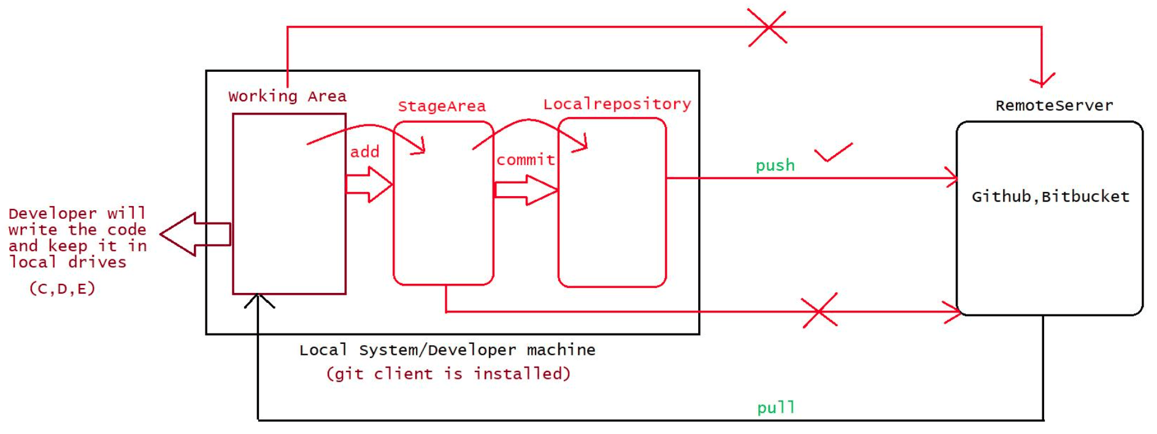

006 GIT AND GITHUB PART - 2

Yesterday Topics
----------------------
1. What is the need of VCS?
2. How many types of VCS?
a. LVCS
b. CVCS
eg: SVN
c. DVCS
eg: GitHub,bitbucket,gitlab,.....
3. Architecture of git
a. working area => devleoper workspace(source code)
b. Stage area => Before adding the code to the localrepository, we
keep the code in stage area
c. Local repository => Before pushing the code to remote repository, we
keep the code in "Local repository".
4. What is git and github?
git -> It is a client tool where the user will enter url,username and
password of github repository.
github-> It is a server where we keep repositories/projects which would
be used for colloboration.
git commands(case sensitive)
=======================
1. git version
2. git help
3. git config
4. git init
5. git clone
6. git add
7. git status
8. git rm
9. git restore
10. git commit
11. git log
12. git show
13.git push
14. git pull
15. git branch
16. git checkout
17. git stash
Note: git merge, git rebase
1. git version
This command is used to check the version of git
syntax: git version or git --version
nitin@DESKTOP-1N5U4UJ MINGW64 ~
$ git version
git version 2.37.0.windows.1
nitin@DESKTOP-1N5U4UJ MINGW64 ~
$ git --version
git version 2.37.0.windows.1
2. git help
If we want to see the list of commands then we can use git help
syntax : git helpNote: This command is useful to get the documentation of any command
eg: git help <command-name>
3. git config
It is used when the git software is used for the first time.
The command will set the devleoper identity like name,emailid,....
This configuration information will be used by git software for every
push operation encounterd.
> git config --list //this command is used to provide the list of
configuration
$ git config --list
diff.astextplain.textconv=astextplain
filter.lfs.clean=git-lfs clean -- %f
filter.lfs.smudge=git-lfs smudge -- %f
filter.lfs.process=git-lfs filter-process
filter.lfs.required=true
http.sslbackend=openssl
http.sslcainfo=C:/Program Files/Git/mingw64/ssl/certs/ca-bundle.crt
core.autocrlf=true
core.fscache=true
core.symlinks=false
pull.rebase=false
credential.helper=manager-core
credential.https://dev.azure.com.usehttppath=true
init.defaultbranch=master
//to set the username and email
> git config --global user.name "Nitin"
> git config --global user.email "javabynitin2022@gmail.com"
global => it indicates the user can work with git commands from different drives of
computer.
Note: git config --list --show-origin //display the location of git configuration
holded by git software
Important operations associated with git
==================================
git init
=> normally a folder will be created in the developers works place and inside the
folder the source code
would be place
=> normally this is the first command which we execute to set up the git for
operations like
clone,push,pull,....
=> This command internally creates one folder called .git
=> .git is used by git software to identify the folder which should participate
in pushing to "local" and
"remote" repositories.
syntax : git init
Note: To change the directory use the following command cd .....
To check in which directory we are currently present we use pwd command
git status> This command is used to check the status of the working directory
> git status
D:\gitsession\Workspace-1(master)
|=> Demo.java
On branch master
No commits yet
Untracked files:
(use "git add <file>..." to include in what will be committed)
Demo.java
nothing added to commit but untracked files present (use "git add" to track)
git status normally will give outputs in the following ways
a. untracked files(red color) => it means the files are present still
in working area and these files
can't be commited to "local repository"
nor to "remote repository"
working area to stage area
b. tracked files(green color) => it means the files are moved from
so these files can be commited to "local
repository" and to
"remote repository".
c. modified files(red color) => it means the files are present still in
working area and these
files can be staged or it
can also be restored back to the
normal phase.
To send the code from workspace to stagearea we use the following command
syntax : git add <file-name>
If we want to push all the files from workspace to stage area,we use the following
command
syntax: git add .
git add --a
It is also possible to unstage the files from stagged area to workspace,using the
following command
syntax: git rm --cached <file-name>
To restore the old file we use the following command
syntax: git restore <file-name>
The files which are ready for commit should be in stage area, to perform commit
operation we use the following command
syntax: git commit -m <some-messages>
eg#1. git commit -m "first commit" //This file commit all the files present
in stage area
file into local repository
eg#2. git commit -m "second commit" filename //This will commit only that
Steps followed to create a remote repository and push it to remote repository
-----------------------------------------------------------------------------------
-----------------------
1. open github.com by providing the credentials
2. create a new repository and enter some name(repository name) and click on
create repository
3. To peform push operation we need to use the following command
git branch -M maingit remote add origin https://github.com/NitinTechnology/Workspace.git
git push -u origin main
Difference between pull and clone
git pull -> it is used to fetch the lastest changes made in remote repository to
working directory.
syntax: git pull
git clone-> it is used to clone the repository to the working directory of the
devleoper.
syntax: git clone <url>
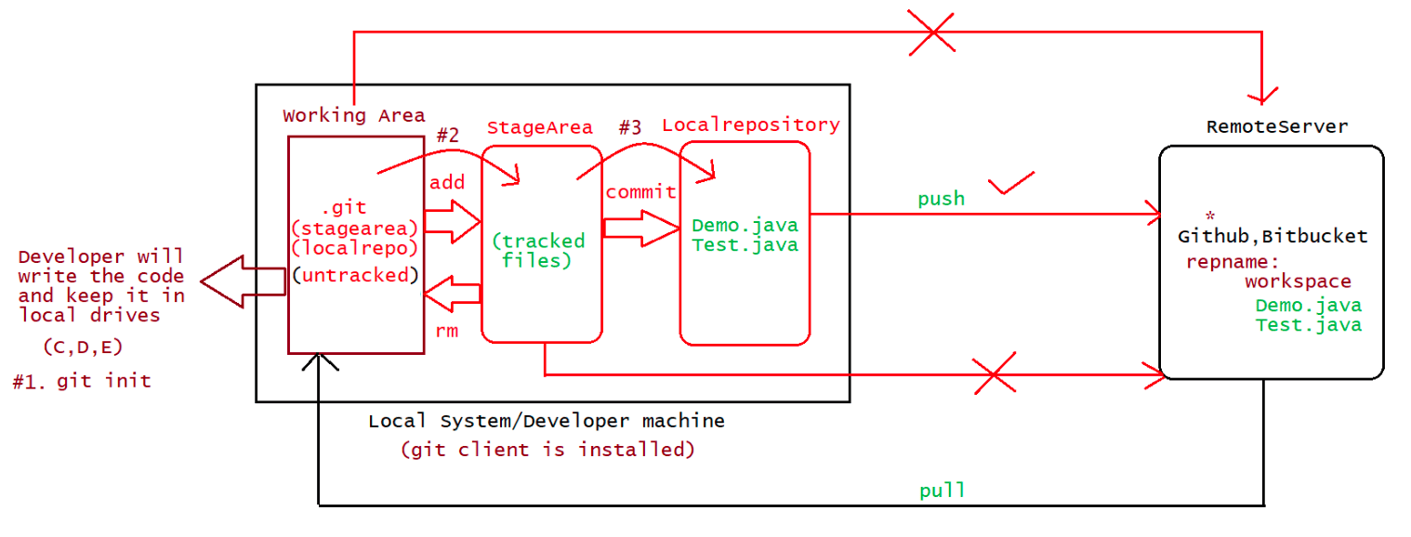
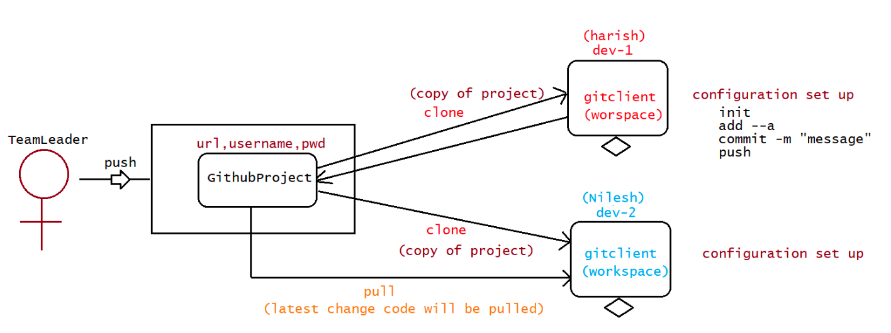

007 DOUBT
Today QA doubts session, not live class QA session : wednesday ( 2PM to 4PM
IST) saturday (6PM to 8PM IST) Live session : monday to friday(7.30PM to
10.30PM IST) Today : Java (Language Fundamentals) from 7.30PM to 10.30PM
IST
Q> Yaa sir please tell once again how to pull the code from remote repository to
working area for cloning any repository we just need the url of the repository but
for pushing it into the repository we required the username and password of that
repository? Answer: git clone < url> //to clone the repository to workspace
git pull // to pull the latest code from repository to worspace
Note: .gitconfig file should be deleted, if it is related to username and email
Q> What happen if a person1 push the changes and the person2 push his
changes without pulling the changes done by person1? Ans: it resolves in
conflict. so always it is a good practise to clone first, followed by pull and then
make the changes and u need to commit.
Q> why we use git config –show -origin ? and what is the difference between
config_list and above one …. which one ll use? git config –list –show-origin
//list the location of files used by git git config –list // list all the details of
config
Q>commands used while pushing from local repo to remote repository? git
branch -M main //in which branch the code should be available git remote add
origin https://github.com/NitinTechnology/Workspace.git // url linking with
remote repository git push -u origin main //pushing the data from local to
remote repository
Q> sir if git is installed in c drive and my work is also getting saved there then
how to change the drive to D where I want to save my local repo/my work
open git bash and type the following commands nitin@DESKTOP-1N5U4UJ
MINGW64 ~ $ cd D: nitin@DESKTOP-1N5U4UJ MINGW64 /d $ cd [folder-
name]
Q> sir how to track history of code? git init // to make workspace to be tracked
by git git add . or git add –a // to push the code from workspace to stage area
git commit -m “message” //all the files present in stage area is pushed to local
repository or git commit -m “message”
git push // to push all the file from local repository to remote repository
Devleoper retrieving git clone < url > //all the files will be clone from remote
to workspace git pull //all the files along with latest changes will be pulled to
workspace
Q> Sir ….if we want to unstage a file back to workplace we will use (git
rm –cached)……what if we want to unstage all the files from stage area? git
rm –cached * //it will unstage all the files from stagearea(trackedfiles) to
workspace(untracked files)
1Q> I have a doubt in DVCS, IS Main server means remote repository? yes.
Q> sir, live class we pushed only .java code can we push an entire folder in git
hub .. collection of files in folder ? yes possible
Q> sir if repository is private, how to access it? only the admin people(team
lead) will access and u will give url,username and password through that u can
access.
Q> sir what is difference between git rm –cached and git restore –staged? git
add Demo.java //just now moved from workspace to stage area git restore —
staged // this command is used to take the recent file added from stagearea to
workspace git commit -m “Mesage”
git add Sample.java
git rm --cached Demo.java //this command is used to take old files added from s
Q> sir can we use git restore –staged for old files too ? git restore // to restore
the files(undo the changes and bring it back) in the working directory.
2

008 First Java program and Main method in Java

why static keyword in main method sir?
public static void main(String[] args)
or
public static void main(String args[])
main -> should be called by jvm and we don't want jvm to create an Object of class
where main() is
present.
If method is static then jvm will call the method directly without
creating an Object.
inside String[] we can keep any type of data but data will be stored
internally as string arguments
only.
why need of command line args
To pass the data from command line to a method during the execution.
sir can you please tell me which version of eclipse I have to download and
install ?
eclipse : 2020-06 version
sir what is difference between war file and .class file?
.class file -> source code converted by a compiler that file is a .class
file
.war file ->collection of many .class files +.html files which is
compressed we call as .war file
.jar file -> collection of many .class files which is compressed we call
as .jar file.
war file -> web application archieve file
jar file -> java archieve file
What happens if we run the java code directly without compile in IDE then
what value is passes to String array?
nothing will be passed
what is difference between print and println ?
System.out.print("sachin");
System.out.print("tendulkar");
output:: sachintendulkar __
System.out.println("sachin");
System.out.println("tendulkar");
output:: sachin
tendulkar
__
what is the purpose of giving arguments at the time of execution,
Code -----> 3 phases before releasing the code to the users
During SpringBoot session we will demonstrate
Devleopment -------> few inputs associated with developer
Testing ---------> few inputs associated with testengineer
Production -----> few inputs associated with QA
either jvm or jre comes into play first ?
code ----> compiled (compiler will come into pitcure) ----> .classfile(bytecodes)
.class should be ready for exeuction
RAM
+++++++++
JRE(java runtime environment)
=> JVM + libraries
+++++++++
you said (main ) is the name of the method is it compulsory to use (main) as the
name
method or any other name?
methods will be written by programmer
public void m1()----> haider
public void m2() ---> nitin
public void m3() ---> naveen
If haider says jvm to start the execute from m1() ----> starting point
If nitin says If arvind says jvm to start the execute from m2() ----> starting point
jvm to start the execute from m3() ----> starting point
To avoid all the is fights b/w developers, SUNMS told the starting point and all
the developers should use
that method only has the starting point.
starting point of exeution for java is
public static void main(String[] args)
or
static public void main(String[] args)
JDK => Compiler + JRE(jvm(JIT compiler) +library tools)
Note: JDK is requried for developers as they write the code and run the code
JRE is required for endusers as they only run the code.
how type of data checked by the compiler during compilation time in dynamically
typed?
statically typed => more work from compiler
dynamically typed => more work at the runtime or during execution
java is statically typed or type checking
byte,short,int,long
byte a=20;
dynamically typed
python,javascript(becoz we don't have datatype there)
statically type
c,c++,java
How we can decide return value i.e 0 OR 1 OR 10 OR something else...?
public int m1(){
;;;;
;;;;
;;;;
return 10;
}
public boolean m2(){
;;;;}
;;;;
//logic will give true or false as the result
return false;

Main Method in Java:
The main() is the starting point for JVM to start execution of a Java program. The main()
method is required for the JVM to execute the program.
The syntax of the main() method is:
public static void main(String [ ] args)
public static void main(String args [ ])
static public void main(String [ ] args)
static public void main(String args[ ])
public static void main(String…args)
Note: public static or static public these access specifiers can interchange their positions.
(More on this will be specified later once we speak these in detail as individual)
public: It is an access specifier. We should use the public keyword to let the JVM know
main() presence in the class(increasing the visibility of the main method).
static : static keyword is used to make the main() method static then jvm will call the method
without creating the object.
(static methods can be called without creating objects – More can be discussed in static
keyword concept)
void : Every method has the return type in Java. void keyword is used to inform the compiler
that the main() method does not return any value.
main: It is the name of the main method in java. JVM will start the program execution from
the main method as it is predefined for JVM hence It must be main and cannot be changed.
String [ ] args : It's the main method parameter to receive command line arguments.
Irrespective of whether the data(arguments) are passed from command line or not, the main
method must contain String []args. If we ignore String [] args from the main method then the
Java file will be compiled but cannot be executed by JVM. Hence it must be required in the
main method.
Note : Kindly also check Q and A pdf attached in resources to get more clarity of concepts
delivered in class.

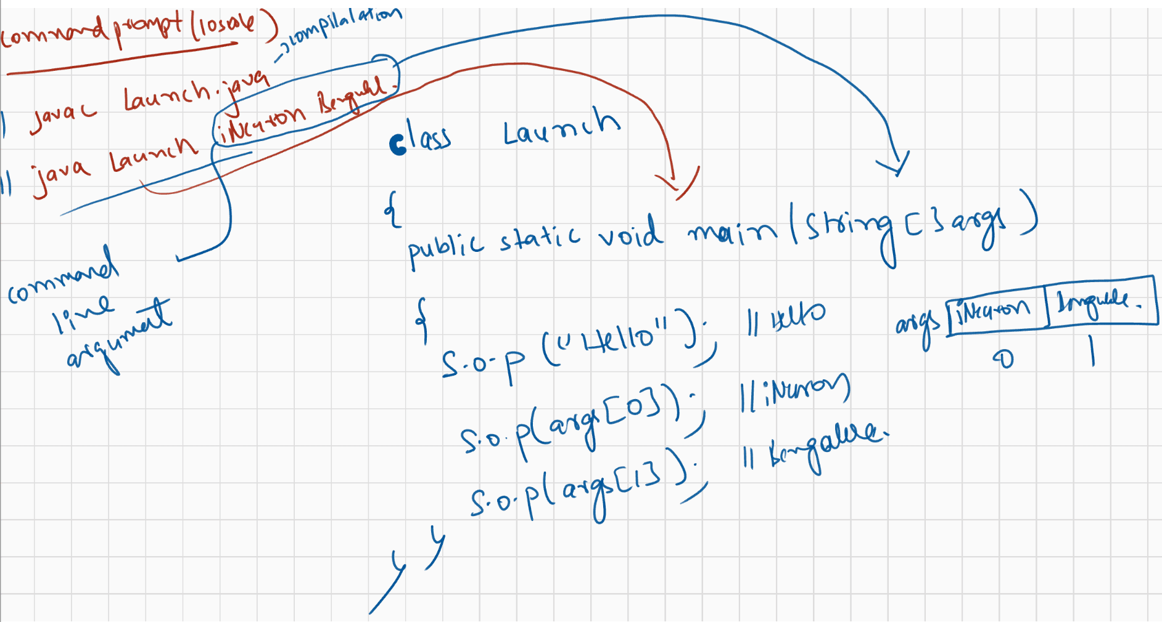

009 Identifiers, Reserved keyword, Data types in Java

Today's topic of discussion
=======================
1. OOPS(basic introduction)
2. Identifier/variables
a. rules to write an identifier
3. Reserved words
4. Data types and its chart.
yesterday topic of discussion
---------------------------------------
1. JShell
2. main method(public static void main(String[] args))
3. command line arguments execution using IDE and command prompt.
OOPS
--------
It stands for Object Orientation Principles.
Object -> real time instance or an entity.
eg: Car,Student,Employee
Every object in realtime will have 2 parts
what it has
what it does
eg: Car
brandName
noOfWheels
model
speed
move
accelerate
brake
Java code
-------------
class Car
{
//HAS part of an Object is represented as a "variable".
String brandName;
int noOfWheels;
//DOES part of an object is represented through "methods"
public void move()
{
//logic of moving a vehicle
}
public void accelerate()
{
}
//logic of acclerating a vehicle
}
#2.
{
class Student
//HAS-part (variables)
String name;
int id;float height;
//DOES-part(methods)
public void study(){
//logic of studying
}
public void play(){
//logic of playing
}
}
Identifier
========
It is a name in java program.
It can be a classname,methodname,variable name and label name.
class Test{
public static void main(String[] args){
int x= 10;
}
}
Totally 5 identifers
eg#2.
class Test{
public static void main(String[] args){
System.out.println("sachin");
}
}
Totally 7 identifiers.
Rules(syntax for compiler + jvm) for writing an identifier
---------------------------------------------------------------------------
Rule1: The only allowed characters in java identifiers are
a to z, A to Z,0 to 9, _(underscore),$
Rule2: If we use any other characters it would result in compile time error
int ^* = 10;(invalid)
int total = 10;(valid)
int total#= 35;(invalid)
Rule3: Identifiers are not allowed to start with digits
int telusko1 =100;(valid)
int 1telusko = 100;(invalid)
Rule4: Java identifiers are case sensitive,meaning number and Number is different.
class Demo{
int number=10;
int Number=20;
int nUmber= 30;
int NUMBER = 40;
}
Rule5: There is no lenght limit on java identifiers, but still it is a good
practise to keep the
length of the identifier not more than 15characters.
int priorityOfThreadWithMinValue = 1;Rule6: We can't use reserve words as a identifers.
eg: int if = 10; //CE
Rule7: Predefined class names can be used as identifiers like String,Runnable
eg#1
String Runnable = "sachin";
System.out.println(Runnable);//sachin
eg#2
int String = 10;
System.out.println(String);//10
Note: Even though predefined class names can be used as an indetifiers,it is not a
good practise to keep.
Interview Question
-------------------------
int If =10;//if and If is different
System.out.println(If);//10
int Integer = 10;
System.out.println(Integer);//10
int int =10;//CE
System.out.println(int);
ReservedWords
--------------------
It is a built in words/keywords which has already a predefined meaning to it.
refer: Reservewords.png
Note:
Literal Any constant value which can be assigned to a variable is called literal
int data =10;
literal -> 10
data -> variableName/identifier
int -> datatype/reserveword
Note: for boolean datatypes the only values allowed for a variable is "true,false",
other than this if we try
to keep any values it would reslut in "CompileTimeError".
=> All reserved words names would start with "lower case ".
=> In java all Classnames/interfacenames would start with "upper case".
Which of the following list contain only reservewords/keywords/builtinwords?
1. final,finally,finalize
ans. finalize is not a reserveword, it is a method in Object class.
2. break,continue,return,exit
ans. exit is not a reserve word, it is a method in System class
3. byte,short,Integer,long
ans. Integer is not a reserve word,it is a predefined class
4. throw,throws,thrownans. thrown is not a reserve word,it is a userdefined variable.
Datatypes
--------------
Every varaible has a type,every expression has a type and all types are strictly
typed/define in java
becoz java is strictlytype /statically typed language.
Compiler role -> Compiler will check the value stored can be handled by
datatype or not
This checking which is done by compiler is
called "TypeChecking/Strictlytype checking".
Primtive datatypes
================
directly.
meaning -> data which is commonly used and supported by any langauge to store
a.Numeric values
=> to store number
a. whole number
b. realnumber
b.character values
c.boolean values
=> to store character type of data
=> to store logical values
Number data
------------------
To store whole numbers we have 4 datatypes
a. byte
b. short
c. int
d. long
datatype information like
a. size of dataype(how much memory is allocated on the ram for that datatype
by JVM)
b. minvalue what it can keep
c. maxvalue what it can keep
note:
System.out.println("Size of byte is :: "+Byte.SIZE);
System.out.println("MINVALUE of byte is :: "+Byte.MIN_VALUE);
System.out.println("MAXVALUE of byte is :: "+Byte.MAX_VALUE);
byte:
size -> 8 bits
minvalue -> -128
maxvalue -> 127
eg:
byte marks=35 //valid
byte marks = 135; //CE: possible loss of precission
byte marks = -1;//valid
byte a = true;//CE: incompatible types
byte b = "nitin";//CE: incompatible types
When to use byte datatype?it is commonly used when we handle the data which is coming from stream,network.
stream -> java.io package
" " -> means String data
' ' -> char data
short
System.out.println("Size of short is :: "+Short.SIZE);
System.out.println("MINVALUE of short is :: "+Short.MIN_VALUE);
System.out.println("MAXVALUE of short is :: "+Short.MAX_VALUE);
size : 16bits(2 byte)
minvalue: -32768
maxvalue: +32767
eg:
short data=137;//valid
short data = true; //CE: incompatible types
short data = "sachin";//CE:incompatible types
Note: This data is not at all used in java and this data type is best sutied only
if u have old processors like 8086.
int:
System.out.println("Size of int is :: "+Integer.SIZE);
System.out.println("MINVALUE of int is :: "+Integer.MIN_VALUE);
System.out.println("MAXVALUE of intt is :: "+Integer.MAX_VALUE);
size: 32bits(4 bytes)
minvalue:-2147483648
maxvalue: 2147483647
eg: int data = 323445;
int result = true;//ce:incompatible types
int result ="pass";//ce:incompatible types
note: The most commonly used datatype for storing whole number is "int" only and by
default if we specify any literal of
number type compiler will try to keep it as "int" only,but we can keep
either in short or byte also.
long
System.out.println("Size of long is :: "+Long.SIZE);
System.out.println("MINVALUE of long is :: "+Long.MIN_VALUE);
System.out.println("MAXVALUE of long is :: "+Long.MAX_VALUE);
size: 64bits(8bytes)
minvalue:-9223372036854775808
maxvalue:9223372036854775807
eg: long data = 10;
long data = 9223372036854775807 ;
If the data goes beyond the range of int,then to keep the data inside long
data type we need to explicitly suffix the
data with 'L' or 'l' otherwise it would result in "CompileTimeError".
eg: long firstData=9223372036854775807;//CE
long secodData=9223372036854775807;//CE
long firstData=9223372036854775807L;have added 'L'
long secodData=9223372036854775807l;
long data = 10L;//now also no problem becoz 10 is int and we
long number = 5l;
Note:
GB's.
When int is not enough to hold the big values, then we use long data type.
When we work with large files, data would come to java program in terms of
long size = file.length();
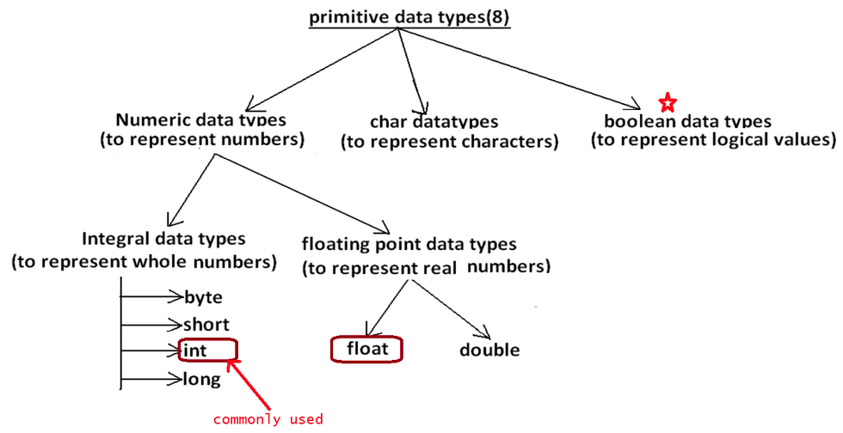
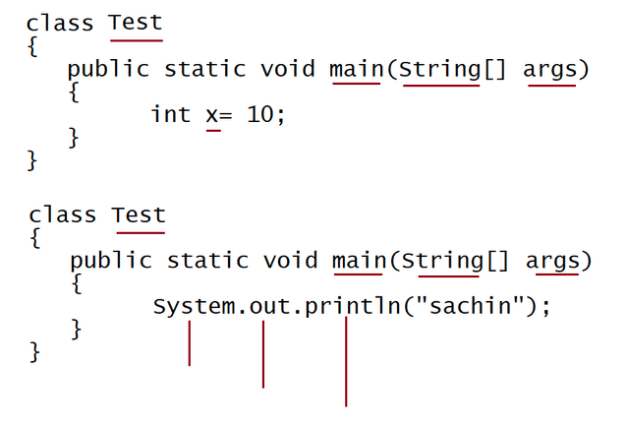
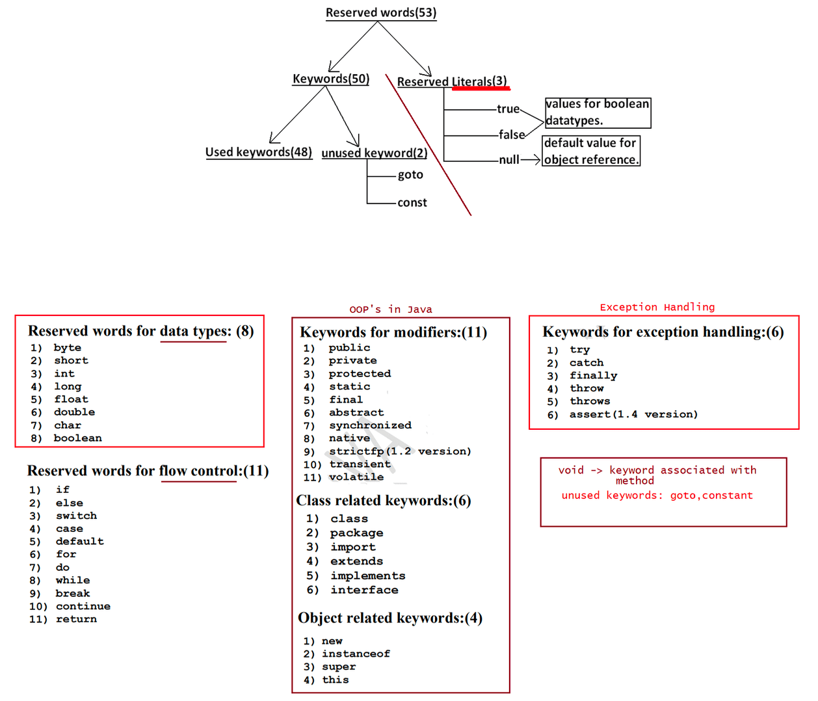

010 Data types and Incrementation , Decrementation operator

yesterday topic of discussion
--------------------------------------
1.Oops(HAS-A part ----> variable)
2. Identifier/variables
a. Rules of identifiers
eg: a-z,A-Z,0-9,$,_
3. Reserve words/keywords/built-in words
4. Datatypes
Datatypes
-------------
Numeric Datatype
a. whole number
1. byte(1byte)
2. short(2bytes)
3. int(4bytes) * commonly used datatype
4. long(8 bytes)
b. realnumber
1. float
2. double
float
------
System.out.println("Size of float is :: "+Float.SIZE);
System.out.println("MINVALUE of float is :: "+Float.MIN_VALUE);
System.out.println("MAXVALUE of float is :: "+Float.MAX_VALUE);
size: 32 bits(1 byte = 8bits, minvalue:1.4E-45
maxvalue: 3.4028235E38
32/8 = 4 bytes)
Note: by default if u specify any real number/decimal number compiler will treat it
as "double", to specify
to the compiler to treat it as float, we need to suffix it with 'F' or
'f'.
eg: float a= 10.5;//CE: possibly loss of precession
float a = 10.5f;
float b = 25.5F;
double
---------
System.out.println("Size of double is :: "+Double.SIZE);
System.out.println("MINVALUE of double is :: "+Double.MIN_VALUE);
System.out.println("MAXVALUE of double is :: "+Double.MAX_VALUE);
size: 64s bits(1 byte = 8bits, minvalue:4.9E-324
maxvalue: 1.7976931348623157E308
64/8 = 8 bytes)
eg: double d = 23.567;
double d = 1.7976931348623157E308;
Note: Datatypes are actually represented to the compiler and jvm using reserve
words.
reserve words are normally in "lower case".
To map primitive data as Object in java from JDK1.5 concept of "Wrapper
class" was introduced in
JDK1.5 version.byte -------------> Byte(C)
short--------------> Short(C)
int --------------> Integer(C)
long --------------> Long(C)
float --------------> Float(C)
double------------> Double(C)
CodeSnippets(JDK8 version)
------------------------------------
For the code below, what should be the name of java file?
1.
public class HelloWorld {
public static void main(String [] args) {
System.out.println("Hello World!");
}
}
A. Hello.java
B. World.java
C. HelloWorld.java
D. helloworld.java
2.
Does below code compile successfully?
public class Test {
public static void main(String[] args) {
System.out.println("Hello");;;;;;;;;
}
}
A. yes
B. no
Ans: A
In java every statement should be terminated with ; symbol
Note: ; means ending.
3.
What is the signature of special main method?
A. public static void main(String args) //[] is missing
B. public static void main(String[] a) //correct
C. public static void main()//missing String[] args
D. private static void main(String[] args)// private can't be for a main method
4.
What will be the result of compiling and executing Test class?
java Test good morning everyone
private class Test{
public static void main(String args[]) {
System.out.println(args[1]);
}
}
A. compilation error //valid answer becoz the main method class can't be private
B. good
C. morning
D. everyone
5.For the class Test, which options, if used to replace /*INSERT*/, will print
"Hurrah! I passed..." on to the console? Select 2 options.
public class Test {
/*INSERT*/ {
System.out.println("Hurrah! I passed...");
}
}
A. static public void main(String[] args) // static and public can be
interchanged so valid
B. public static void main(String[] a)//valid
C. static public void Main(String[] args)
D. public void main(String[] args)
E. protected static void main(String[] args)
F. public void static main(String[] args)//here static and void is interchanged is
not possible
6.
Suppose you have created a java file, "MyClass.java".
Which of the following commands will compile the java file?
A. javac MyClass //invalid becoz .java is missing
B. java MyClass // javac is command is used for compilation
C. javac MyClass.class //invalid becoz .java is missing
D. javac MyClass.java //valid
E. java MyClass.java //javac is the command for compilation and java is command
for execution

public class DataTypes {

public static void main(String[] args) {

double a=0;
double b=0;
double c=a/b;
//System.out.println(c);

byte num1=45;
double num2;
num2=num1;

//System.out.println(num2);

double d=45.5;
byte e;

e=(byte) d;
System.out.println(e);

byte ab=10;
byte ac=20;
int result = ab*ac;
System.out.println(result);

}

}

public class IncDec {

public static void main(String[] args) {
// TODO Auto-generated method stub

//int a=5;
//System.out.println(a);
//a++;
//++a;
//System.out.println(a);

int a=5;
int b;
b=a++ + --a - a-- - a++;
System.out.println(a);
System.out.println(b);

}

}

public class Launch1 {

public static void main(String[] args)
{

System.out.println("Hello");
}

}

